|  |  |  |  |  |  |  |  |  |
| --- | --- | --- | --- | --- | --- | --- | --- | --- |
| Sr. No | Department | Laptop | Staff Room | For Students | Number of computers with Internet Connection | No of Browsing Centres | Total | Not Working Condition |
| 1 | Office | 02 | Office-11  Principal-1 | 0 | 12 |  | 14 | 00 |
| 2 | Libray |  | Staff-3 | 0 | 11 | 01 | 11 | 03 |
| 3 | Computer Science |  | 04 | 0 | 67 |  | 67 | 05 |
| 4 | Electronics |  | 3 pc+ 1Ncomputing+  10 old pc shifted from cs |  | 01 |  | 14 | 06 |
| 5 | Physics |  | Staff-3 |  | 01 |  | 03 | 01 |
| 6 | Maths |  | Staff-1 |  | 01 |  | 01 | 00 |
| 7 | Botony |  | 1 |  | 01 |  | 01 | 00 |
| 8 | Bio Technology/Bio Chemistry |  | 05  02-teaching ICT  1-Connectd to instument | 00 | 05 |  | 22 | 15 |
| 9 | chemistry |  | 02 | 03 | 01 |  | 05 | 00 |
| 10 | Zoology | 04 | 02 |  | 01 |  | 06 | 00 |
| 11 | Marathi | 01 | 01 |  | 01 |  | 01 | 00 |
| 12 | Arts Staff Room |  | 02 |  | 01 |  | 01 | 00 |
|  |  |  |  |  |  |  | 146 | 30 |

Total Computers 2017-18

Total Number of computers in working condition=116

16/03/2018

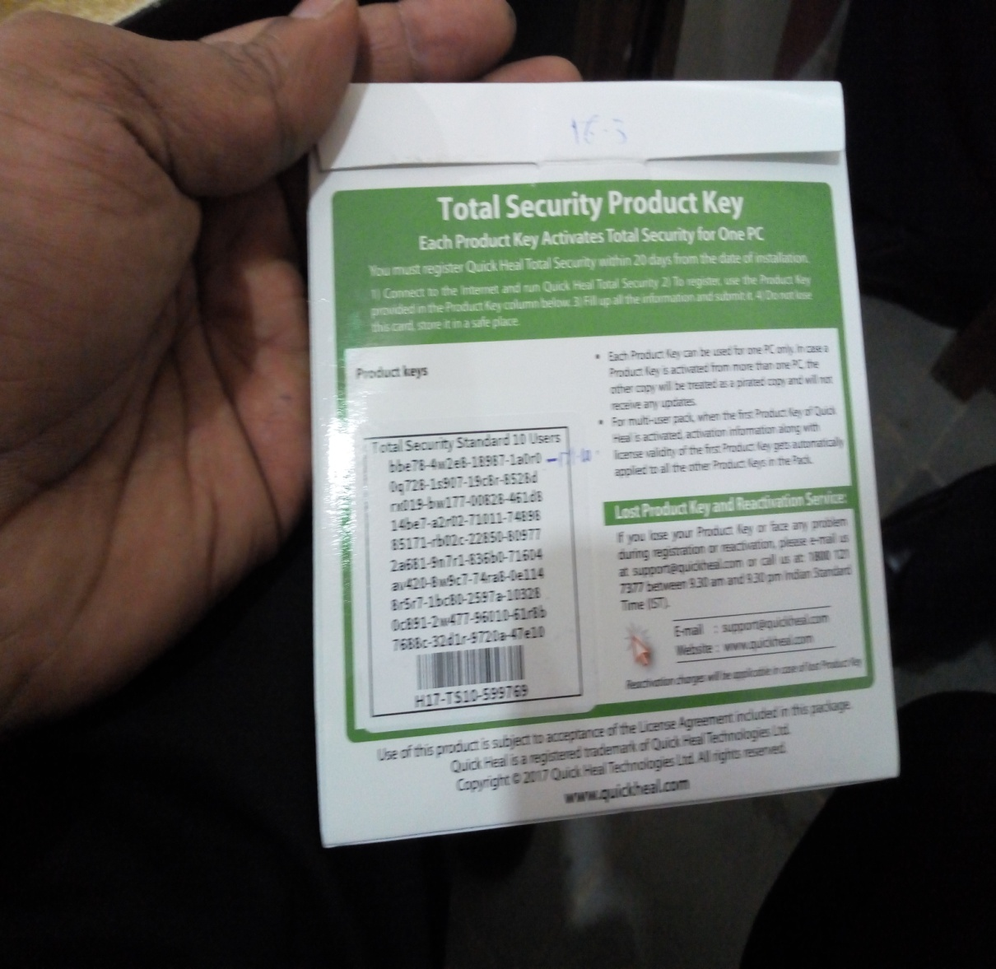

2018-19

20/07/2018-----------2 Ncomputing purchased

20/07/2018-------12 Computers were purchased

(Libray-1,Zoology-01,Biotech hod -2,Biotechnology lab-08)

20/07/2018-Two Windows 10 Professional OS were purchased.

30/07/2018 –two ups were purchased

20/7/20118-25 spike gurd

20/7/2018-10 mouse,1 switch

06/08/2018- 2ups1 Printer,10 antivirus with 3 years anti virus were purchased( will expire on 04 August 2021)

06-dec-2019 old antivirus will expire.

Anti virus- Placed in

Principal-1

Zoology-1

NComputing-4

Library-1

Computer Science-1

Chemistry-1

Arts Staff Room-1

20/10/2018- 52 4gb Ram replaced in dell computer

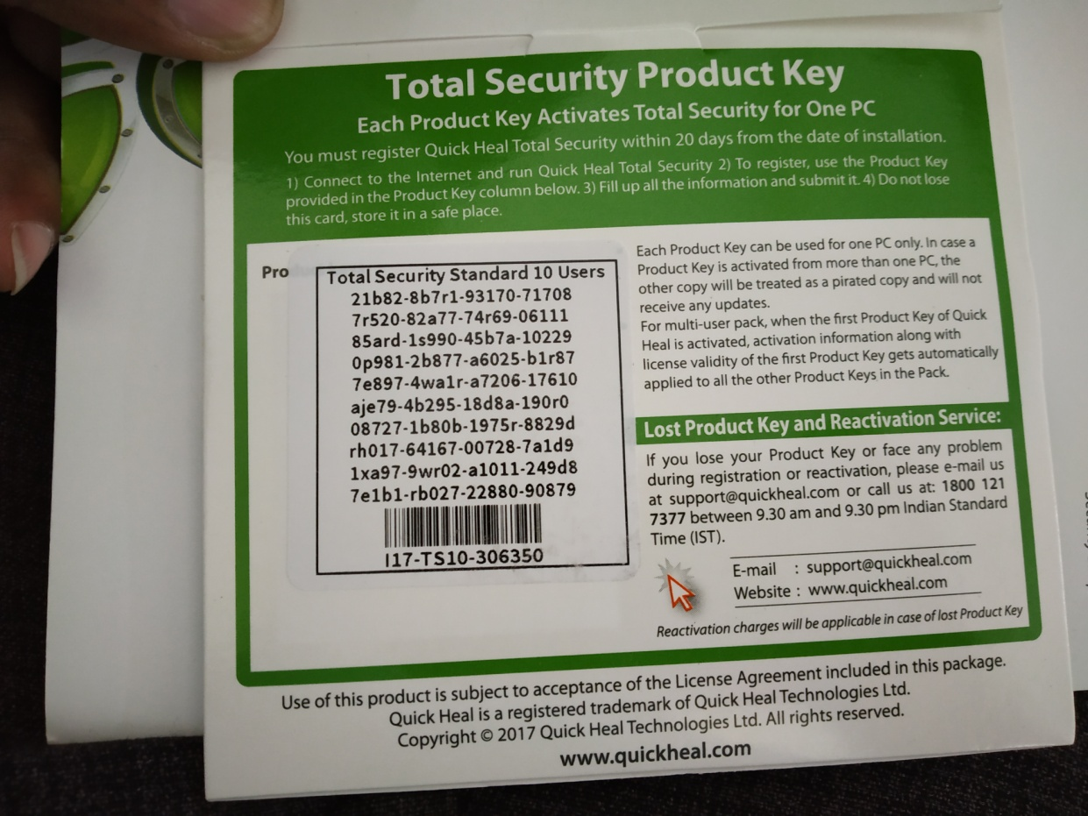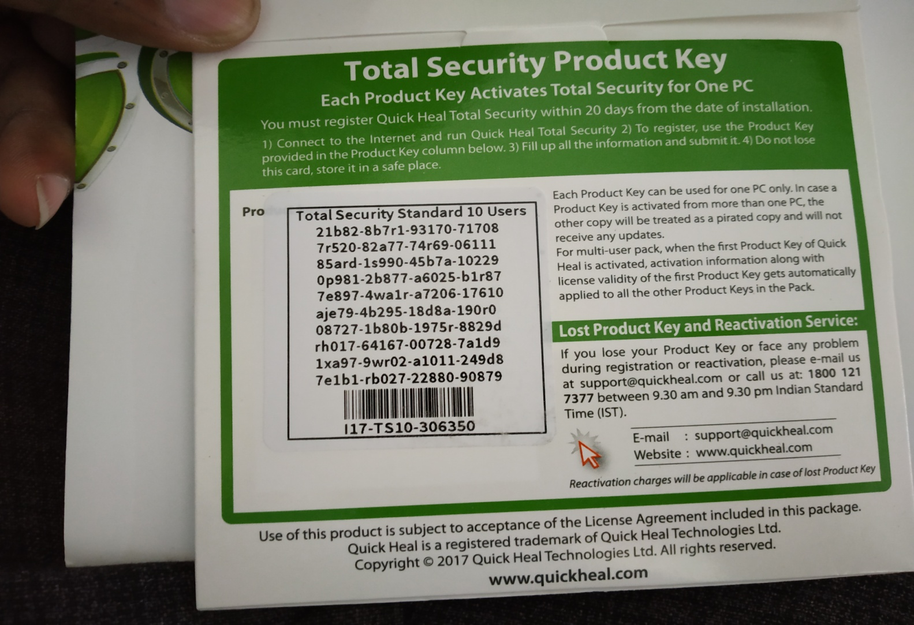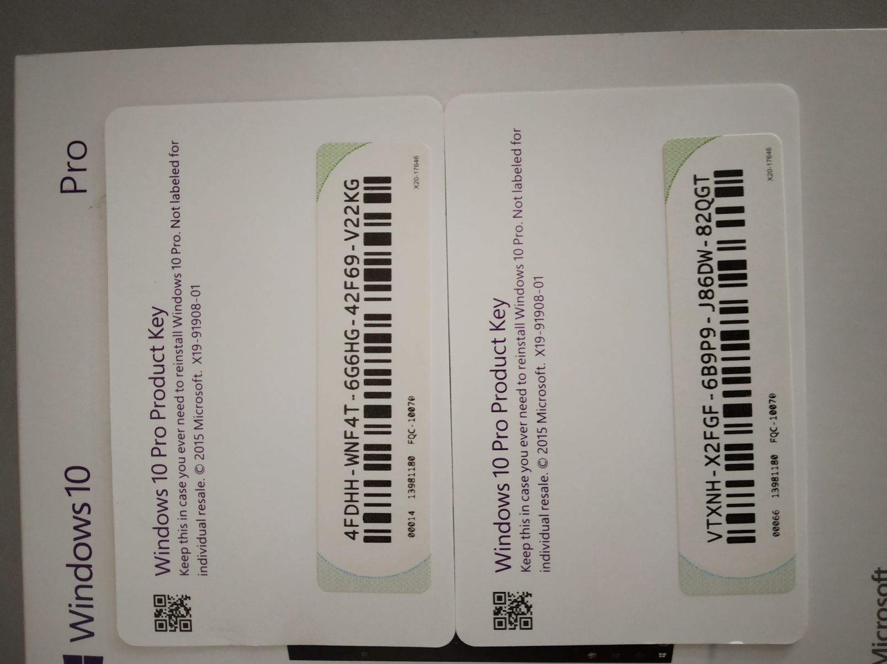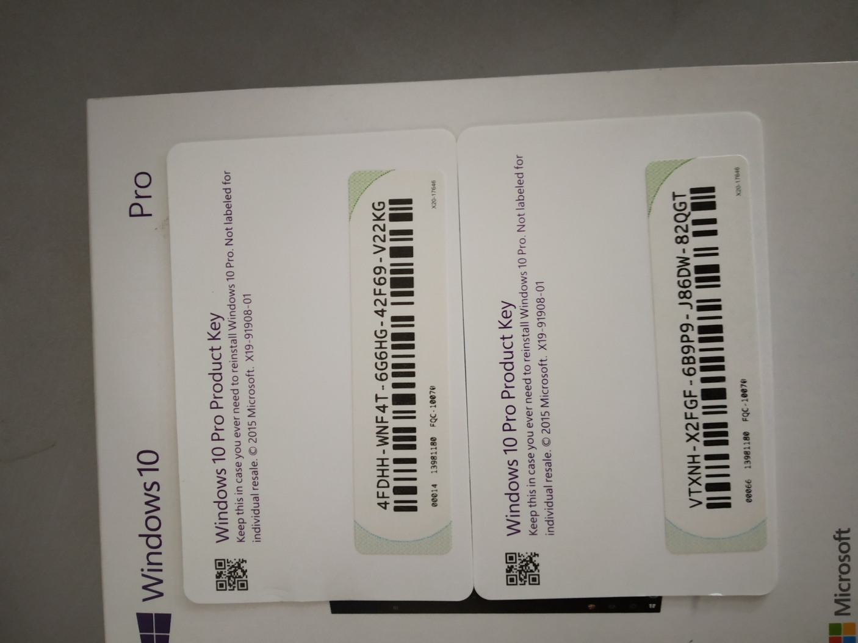

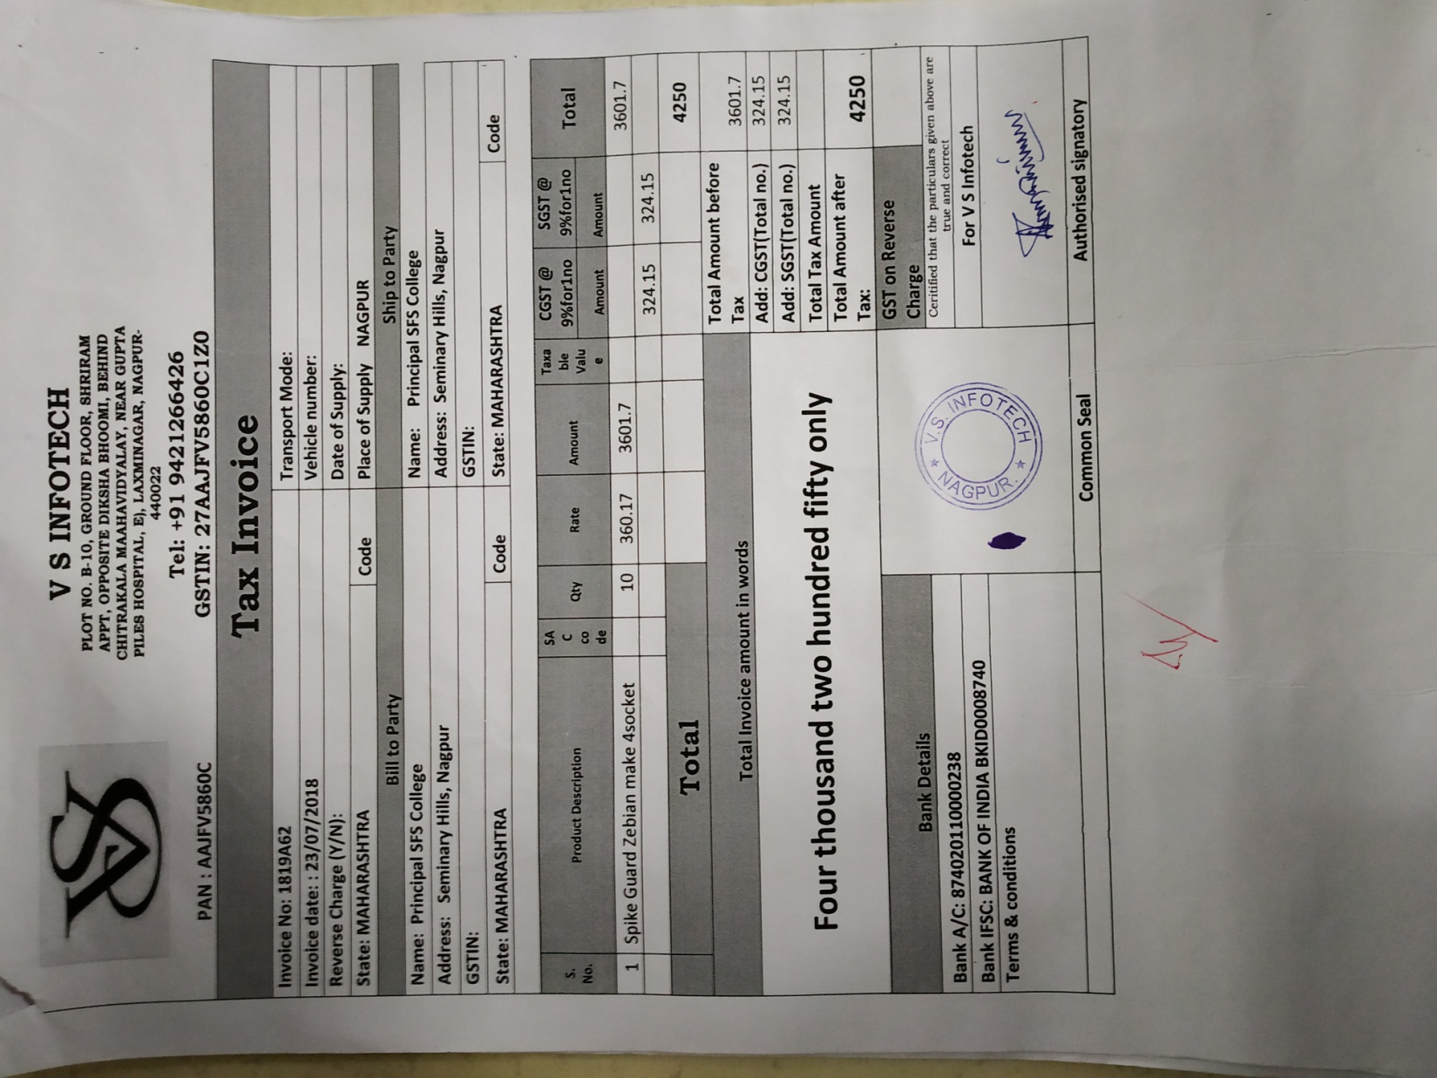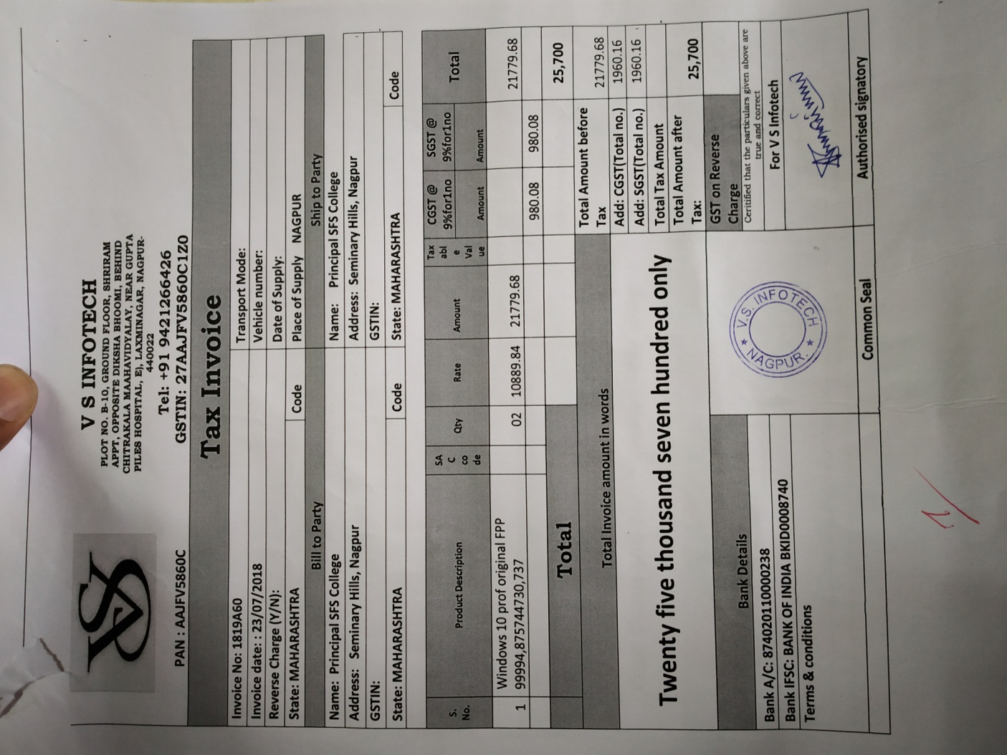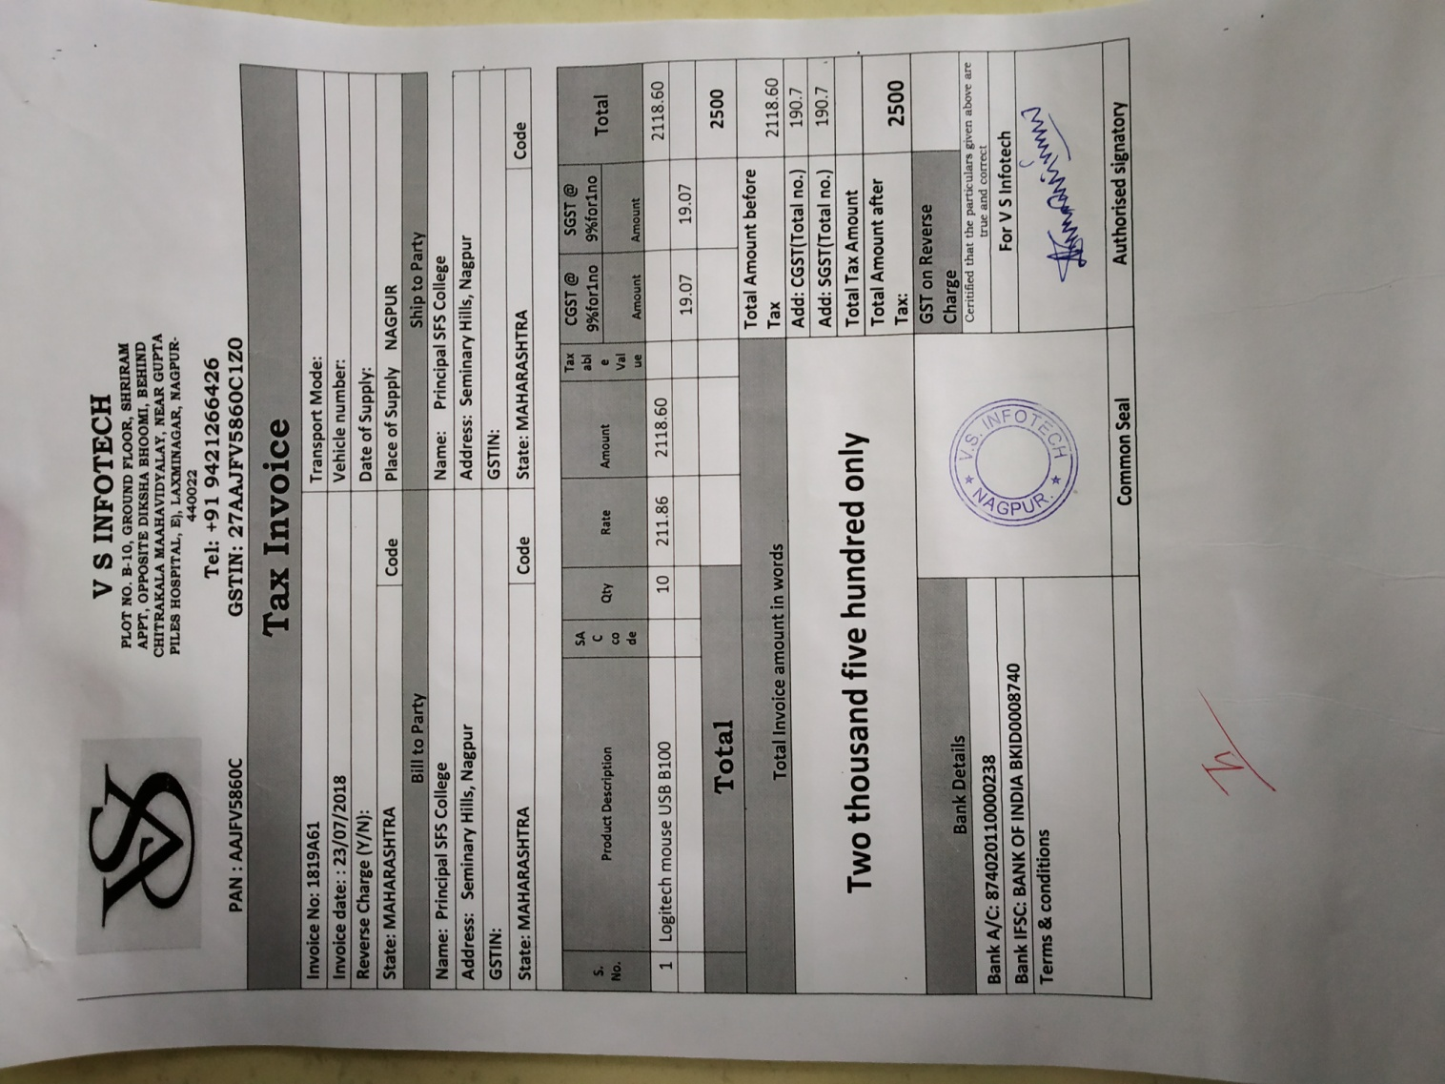

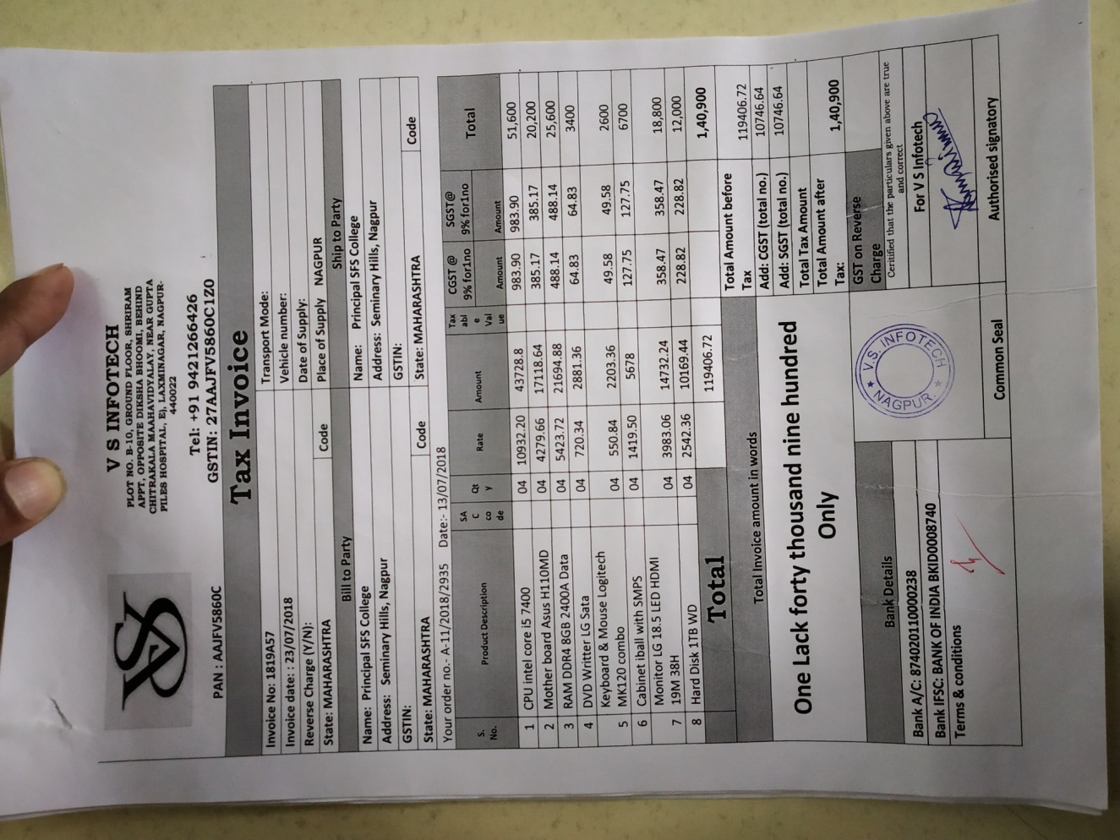

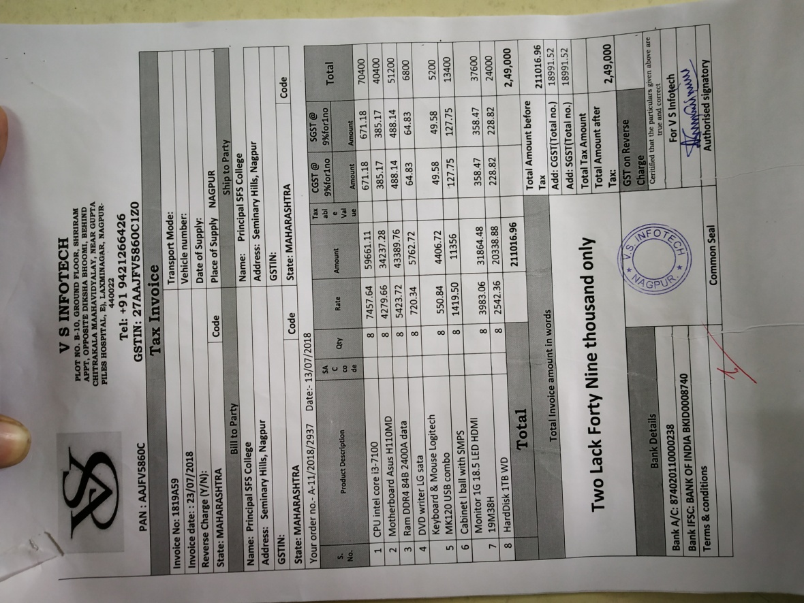

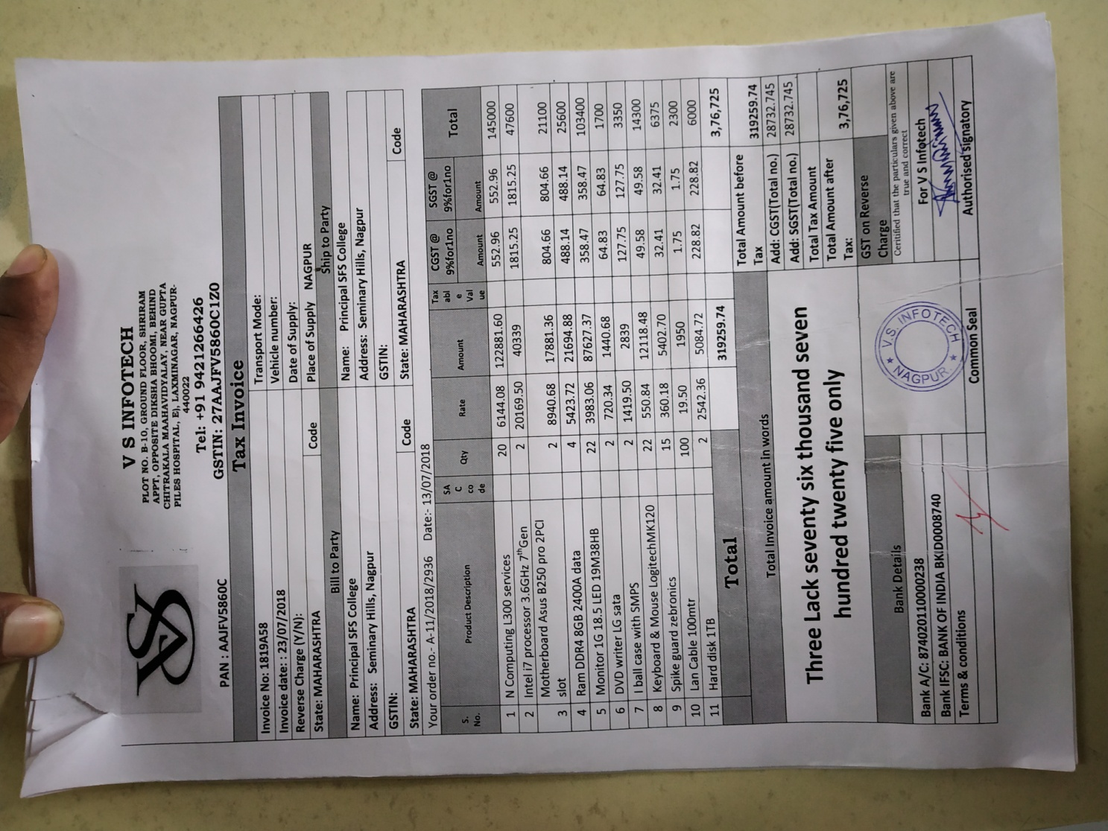

BSNL BILL

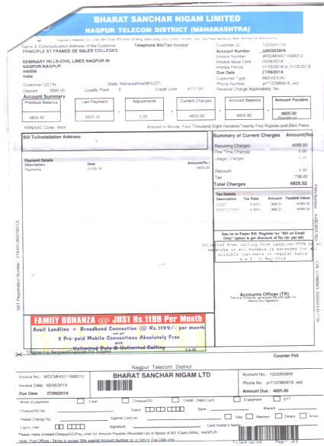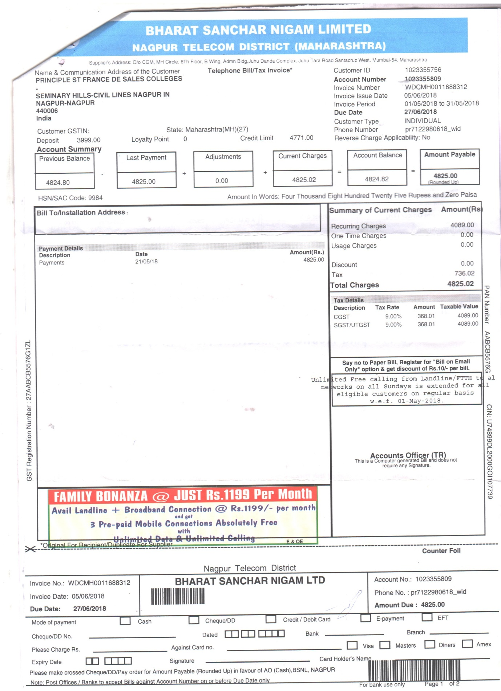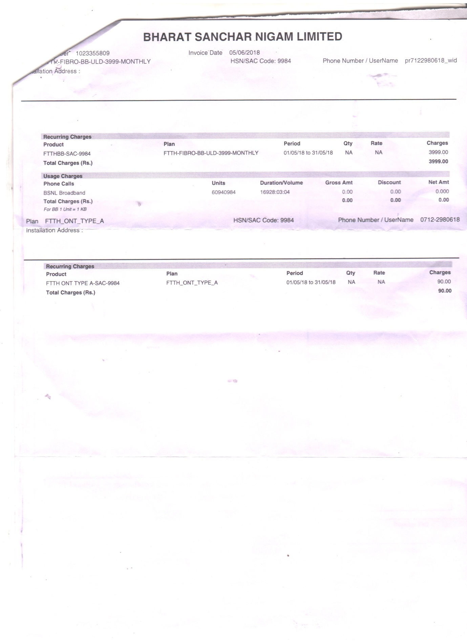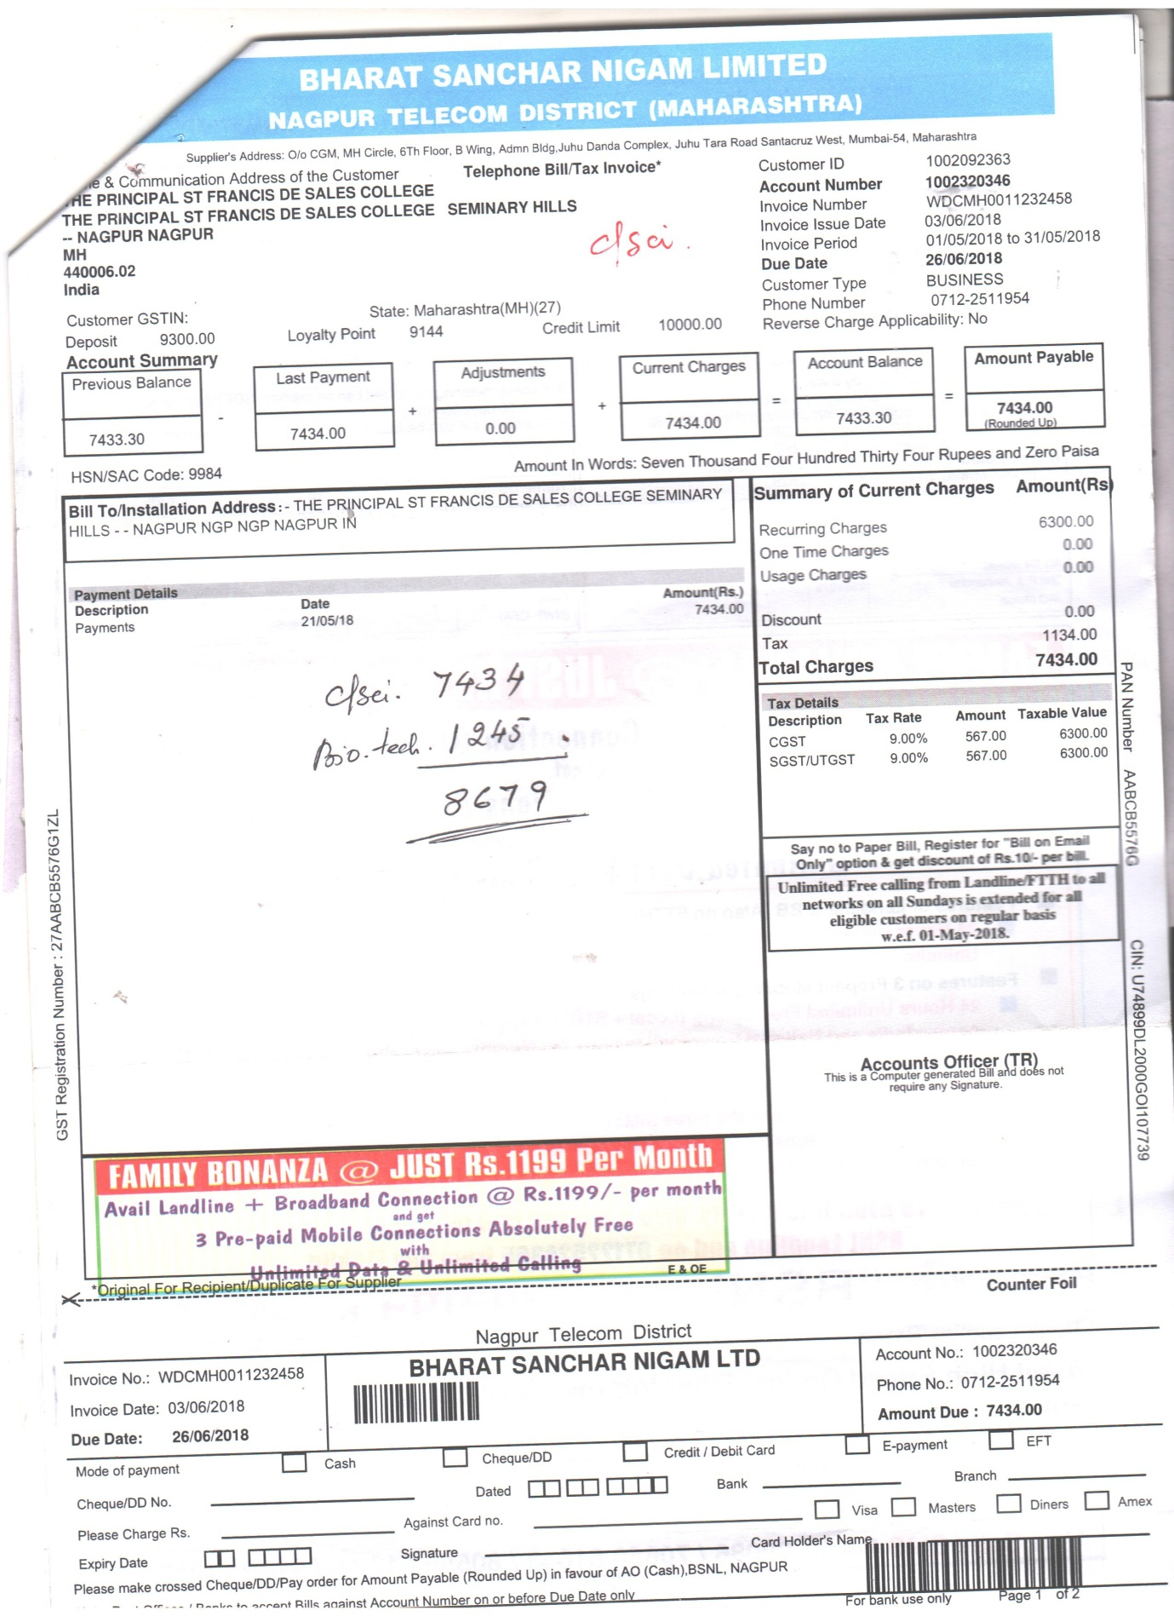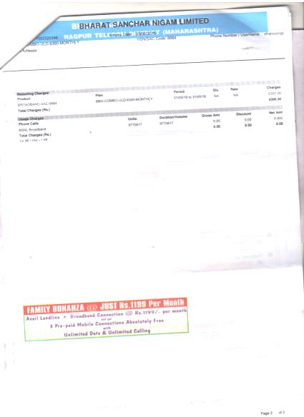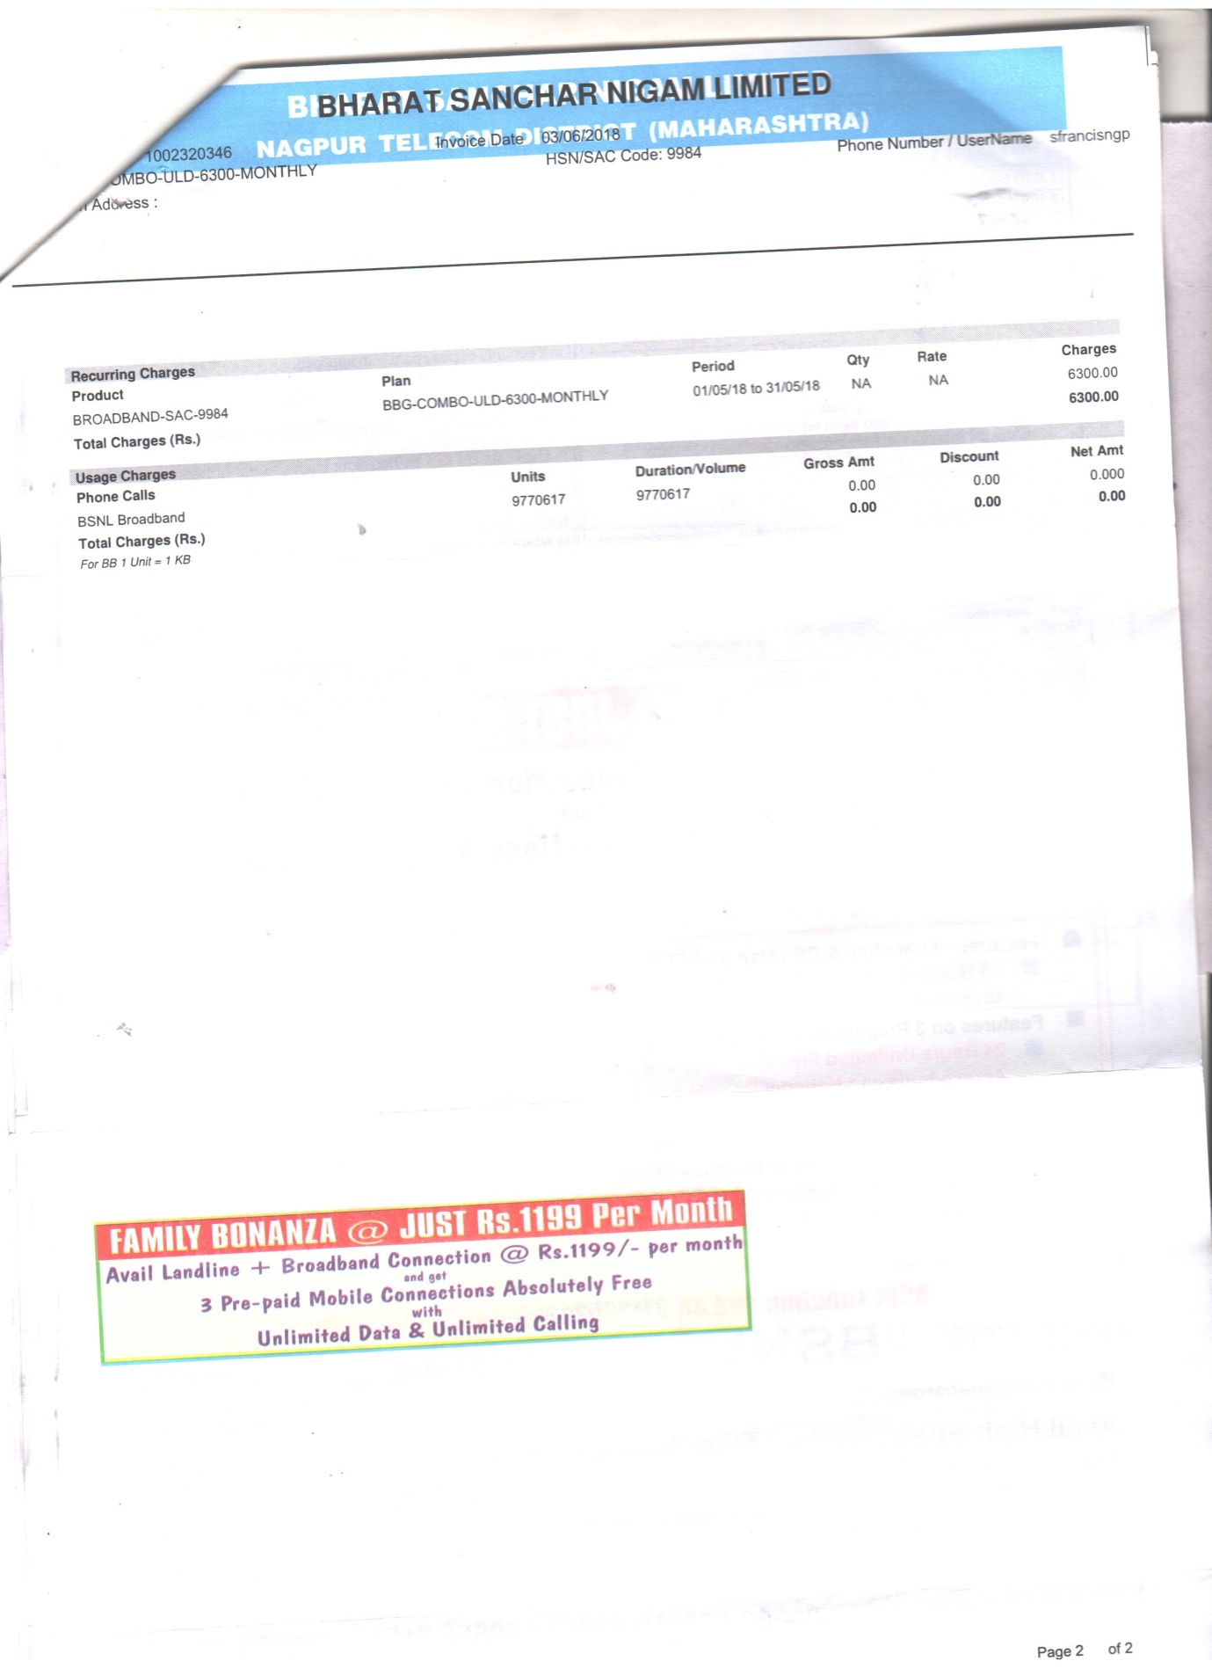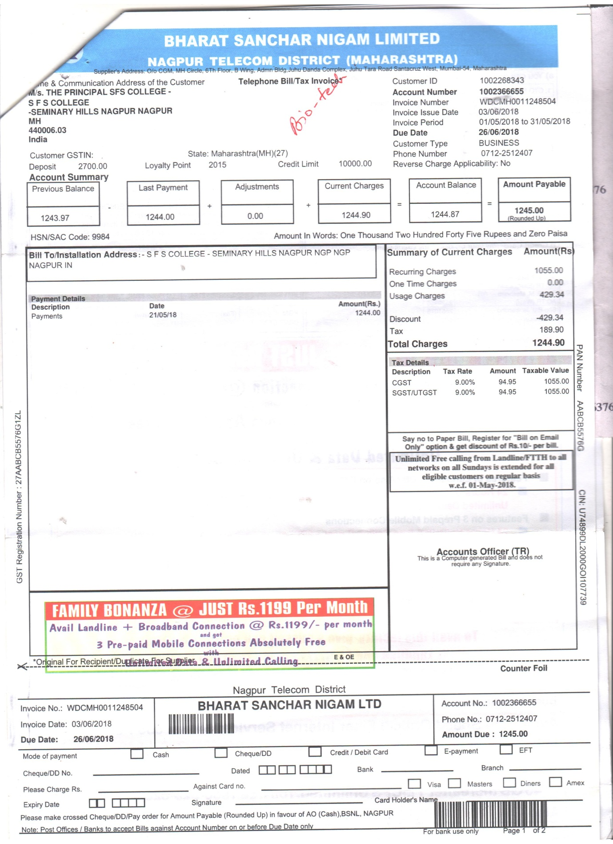

22/01/2019

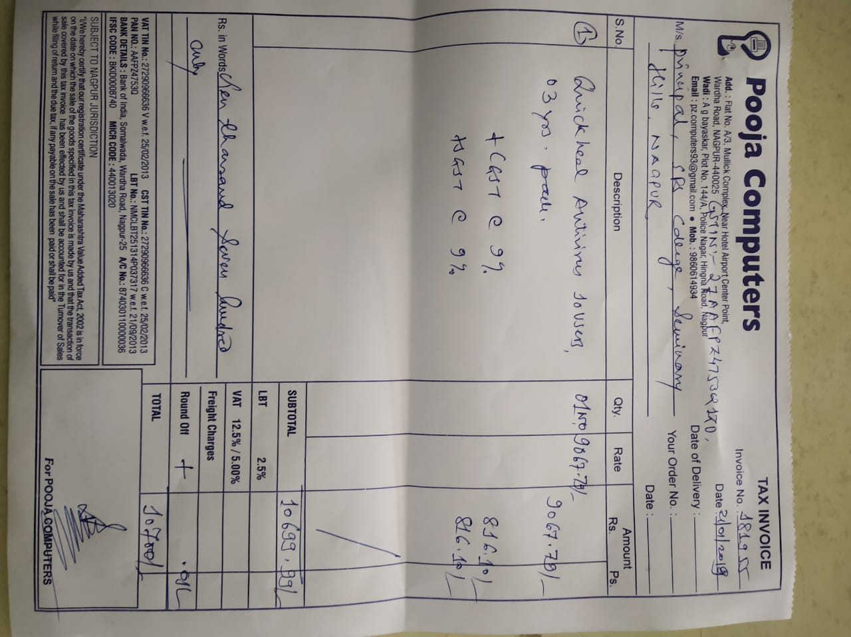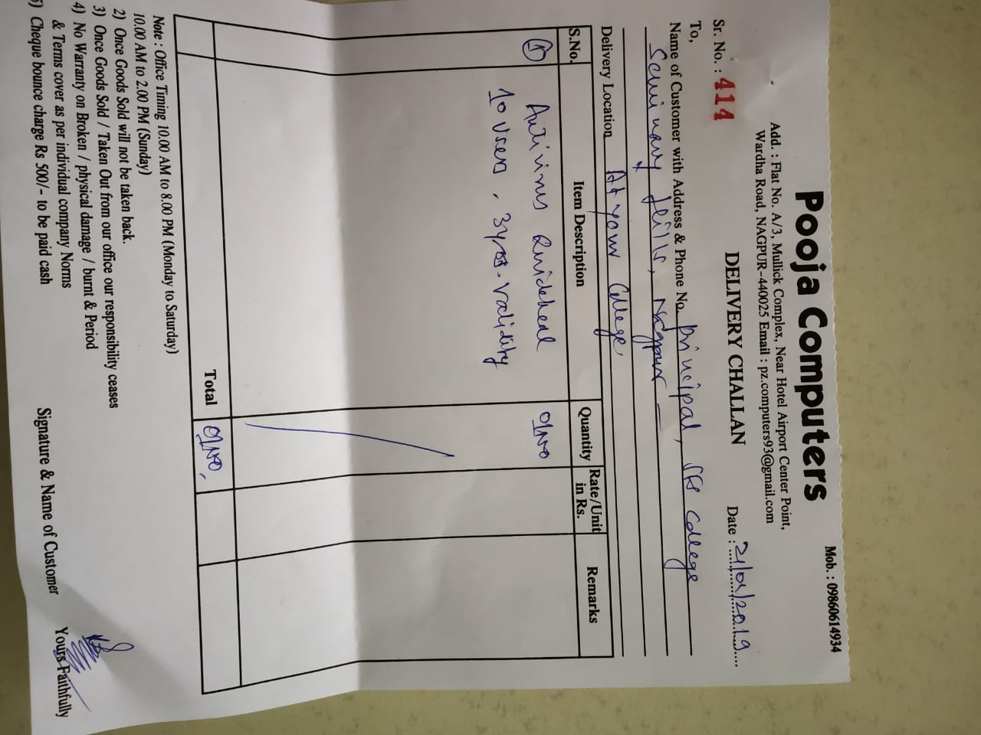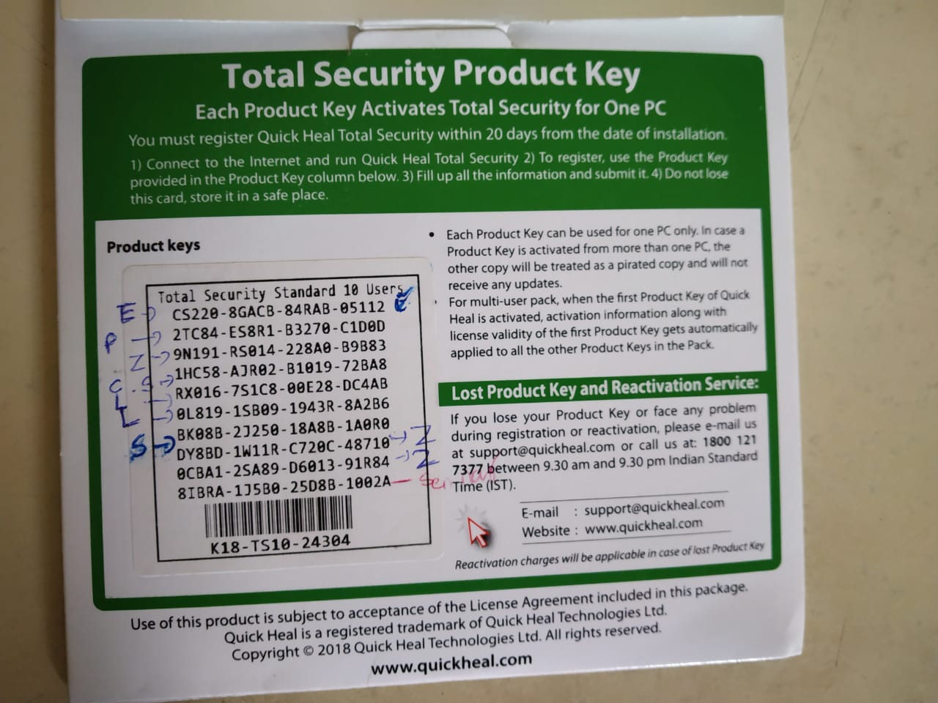

22/01/2019

**Windows Pro Electronics Department key**